# Disc Golf at BYUI

## Brother Alvey

## WDD 130

## Overview

### Purpose

To inform students and local members of the community about the 9-hole disc golf course on the BYUI campus. And to teach about the basic rule of disc golf and how to play.

### Audience

Students at BYUI and other locals interesting in disc golf.

## Branding

### Website Logo



## Style Guide

### Color Palette

|  |  |  |  |
| --- | --- | --- | --- |
| **Primary** | **Secondary** | **Accent 1** | **Accent 2** |
| #96CADA | #023554 | #408251 | #F3C234 |
|  |  | #B75139 |  |

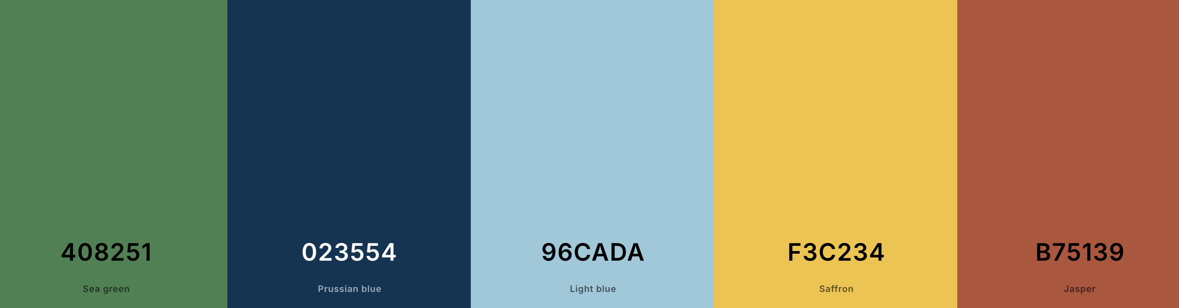

### Typography

#### Heading Font: Giants

#### <https://www.dafont.com/giants-2.font>

#### Paragraph Font: Pompadour

#### <https://www.dafont.com/a-pompadour.font?psize=s&text=The+quick+brown+fox+jumped+over+the+lazy+dog>.

#### 

### Navigation

Home Holes Disc Golf Rules

Home – Home page with a hero image and some pictures of the course and some discs and some baskets

Holes – Picture and description of each of the 9 holes.

Disc Golf Rules – Text describing the rules and object of the game of disc golf

**Content**

Home Page Content

One of my favorite spots in Rexburg is the disc golf course right on the BYU–Idaho campus. It’s a 9-hole course that’s perfect for beginners and amateurs—it’s fun, approachable, and still offers enough challenge to keep every round interesting. The layout makes great use of the campus scenery, so it’s not just a good workout but also a really enjoyable way to spend time outdoors with friends or unwind between classes. Whether you’re new to disc golf or just looking to sharpen your skills, it’s the perfect place to play.

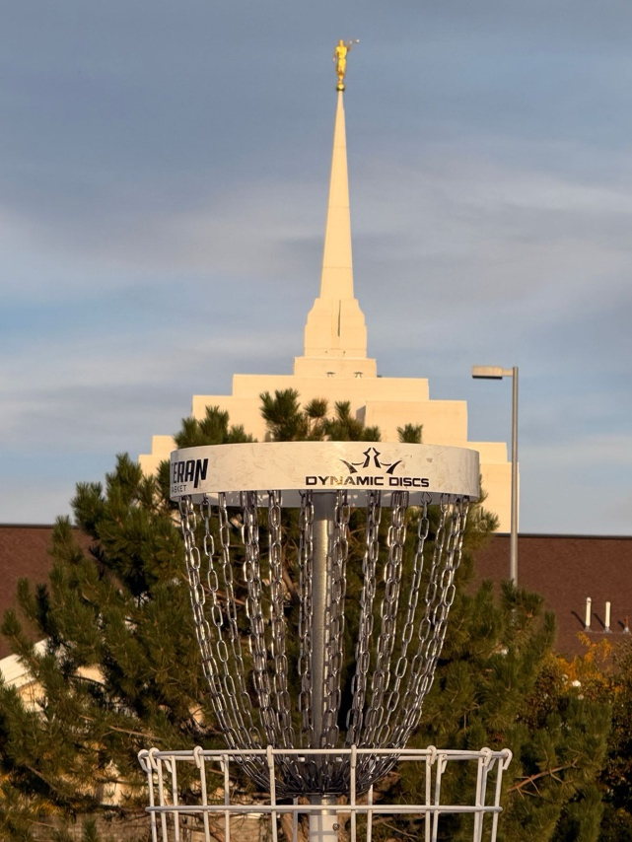

The course at BYU-I is located just below the beautiful Rexburg Temple surrounding the soccer fields and the ropes course.

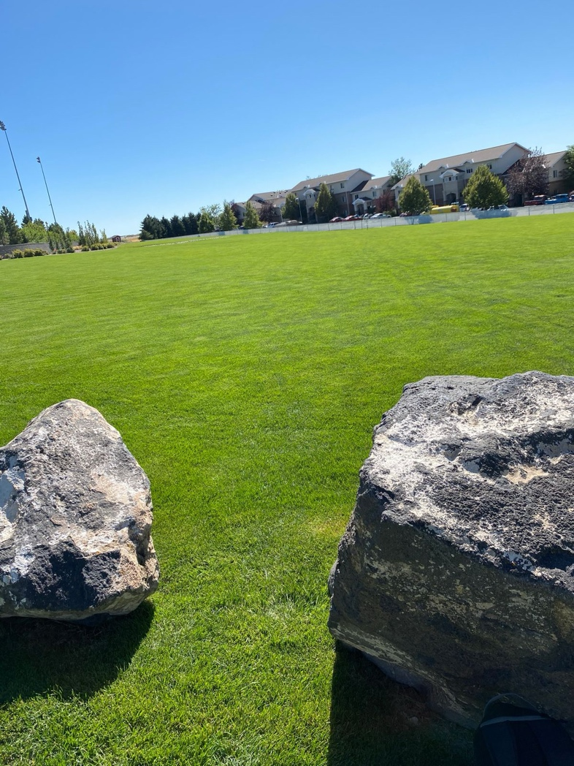

Good mix of holes with some easy par 3 shots and some challenging par 4 shots.

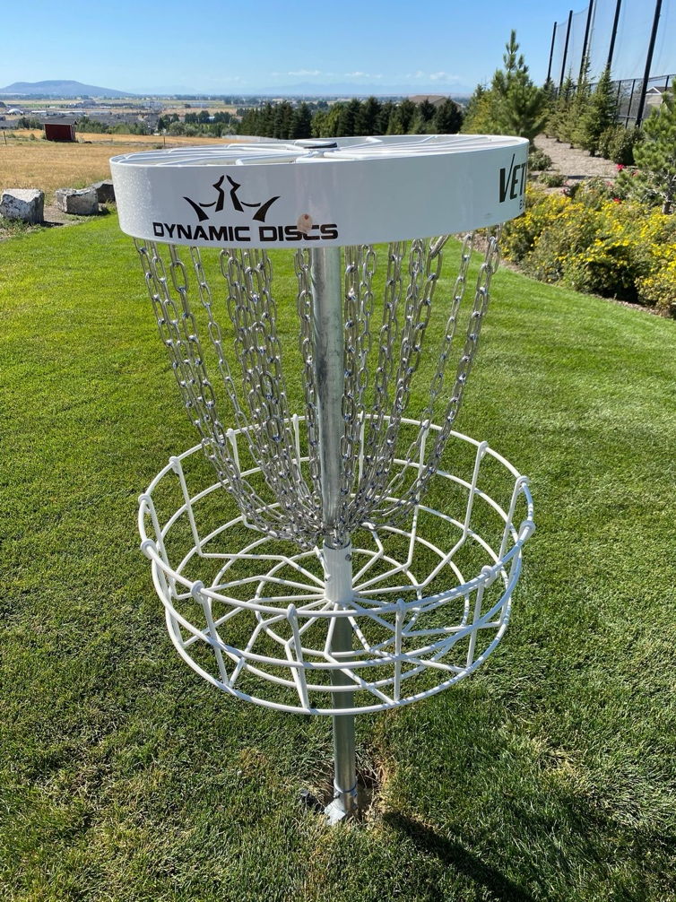

Well maintained baskets with decent Tee pads, thought they are not cement and can get a little muddy.

**Holes Page:**

Hole #1

Distance: 288ft

Par: 3

Clear shot downhill

Careful not to overthrow this one into the mud volleyball pit

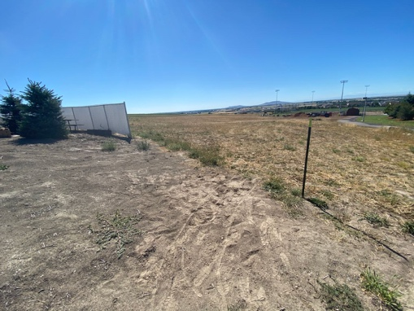

Hole #2

Distance: 612ft

Par: 4

Long shot that bends around the soccer field. Be careful not to go to the right or you will have to walk all the way around the fence to retrieve your disc.

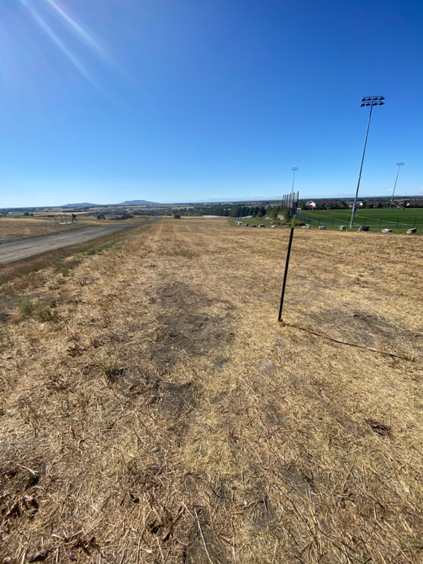

Hole #3

Distance: 465ft

Par: 4

Medium distance with a sharp right turn at the end. Lots of bushes and trees in the out of bounds to the right, rock river hazard running through the middle. Great hole for a lefty or a good forehand through.

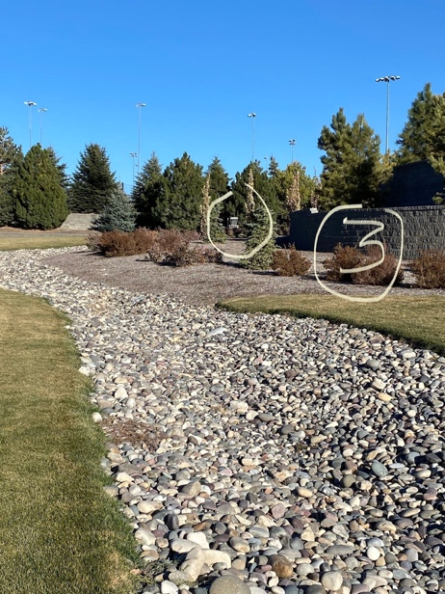

Hole #4

Distance: 229ft

Par: 3

Short hole with a slight right bend, great birdie opportunity with a midrange disc. Be careful not to go into the trees. Another left hander shot.

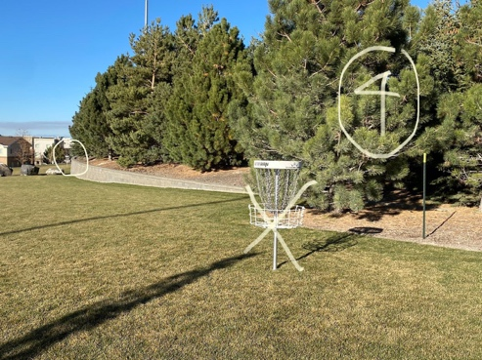

Hole #5

Distance: 226ft

Par: 3

Clear open shot in the middle of a flat grassy field. All you have to do is throw it straight and try not to overthrow it. Another great opportunity for a birdie.

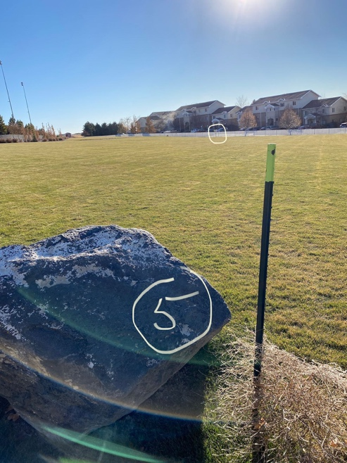

Hole #6

Distance: 349ft

Par: 3

This is a tricky shot to stay in bounds. You have a thin strip of grass that is in bounds and it is on the perfect flight path for a right handed back hand throw. It is a steeper incline than it looks and there are thick bushes on the left that have eaten more than one disc.

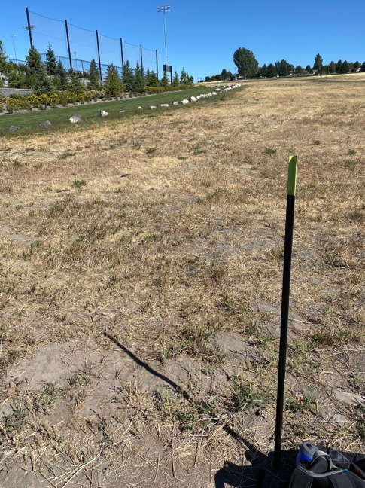

Hole #7

Distance: 420ft

Par: 4

Wide open straight shot, but it is uphill and hard to get it to glide very far. Don’t throw it too high or too low. Throw it straight and it is not a difficult par 4.

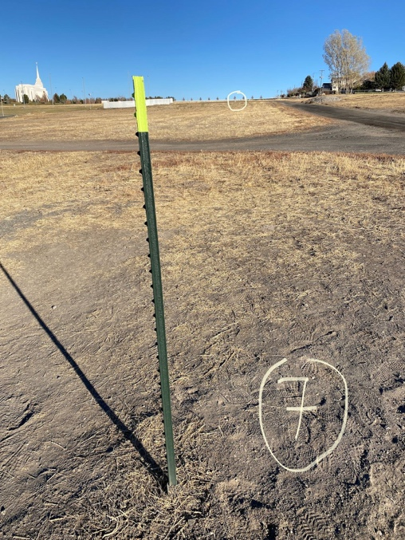

Hole #8

Distance: 514ft

Par: 4

This is a fun hole. It is a little long, but it is down hill and you can really get some glide time. I have my longest throw on this hole. Keep it straight and you have a great opportunity for a birdie.

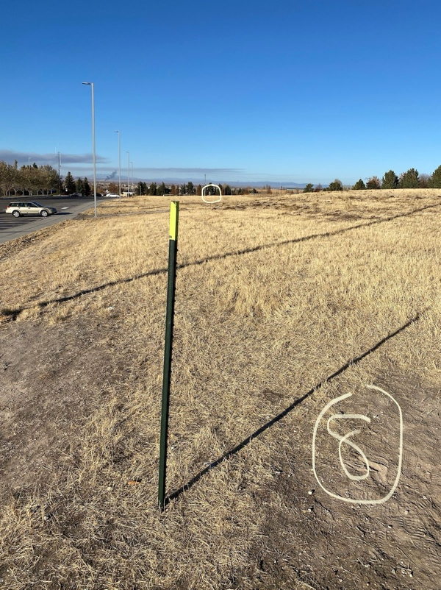

Hole #9

Distance: 400ft

Par: 4

Coming right back up hill from hole 8, this one is a wide open shot. Keep it straight and it is an easy par. Trees on the left are not too bad, but they can block your approach on your second show, so keep right.

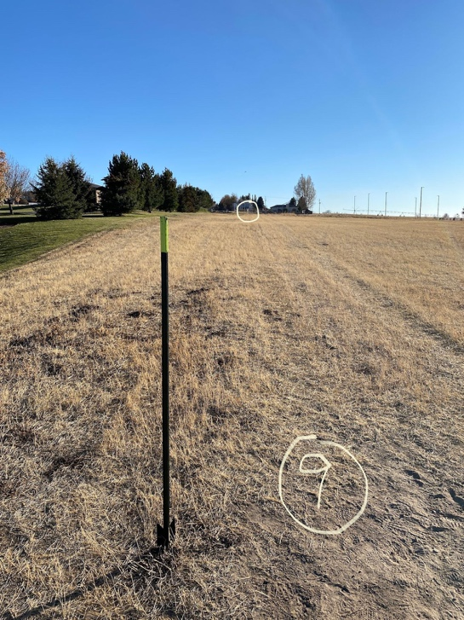

**Disc Golf Rules Page:**

Disc golf is played much like traditional golf, but instead of hitting a ball into a hole, players throw a flying disc (Frisbee) into a metal basket with hanging chains. The goal is to complete each hole in the fewest number of throws.

Objective

Finish the course (typically 9 or 18 holes) with the lowest total number of throws, just like golf.

Basic Rules

1. *Starting the Game*

Each player begins at the tee area.

The order of play is decided randomly for the first hole; afterward, the player with the lowest score on the previous hole tees off first.

2. *Throwing the Disc*

After the first throw, the player whose disc is farthest from the basket throws next.

Throws are made from the spot where the previous throw landed.

The disc must be thrown, not handed or kicked.

3. *Tee Throws*

Must be made from within the designated tee area.

4. *Fairway Throws*

The player’s foot must be directly behind the disc’s lie (the spot where it landed).

You may not step past the lie until after the disc is released.

5. *Putting*

A putt is any throw made within 10 meters (33 feet) of the basket.

The player must maintain balance—no stepping past the lie—until the disc comes to rest.

6. *Completion of a Hole*

A hole is completed when the disc comes to rest in the basket or chains.

7. *Out of Bounds (OB)*

If a disc lands out of bounds, a one-throw penalty is added.

The next throw is made from where the disc last crossed in bounds.

8. *Scoring*

Each throw counts as one stroke.

Lowest total strokes after all holes wins.

**Wireframes**

### Home

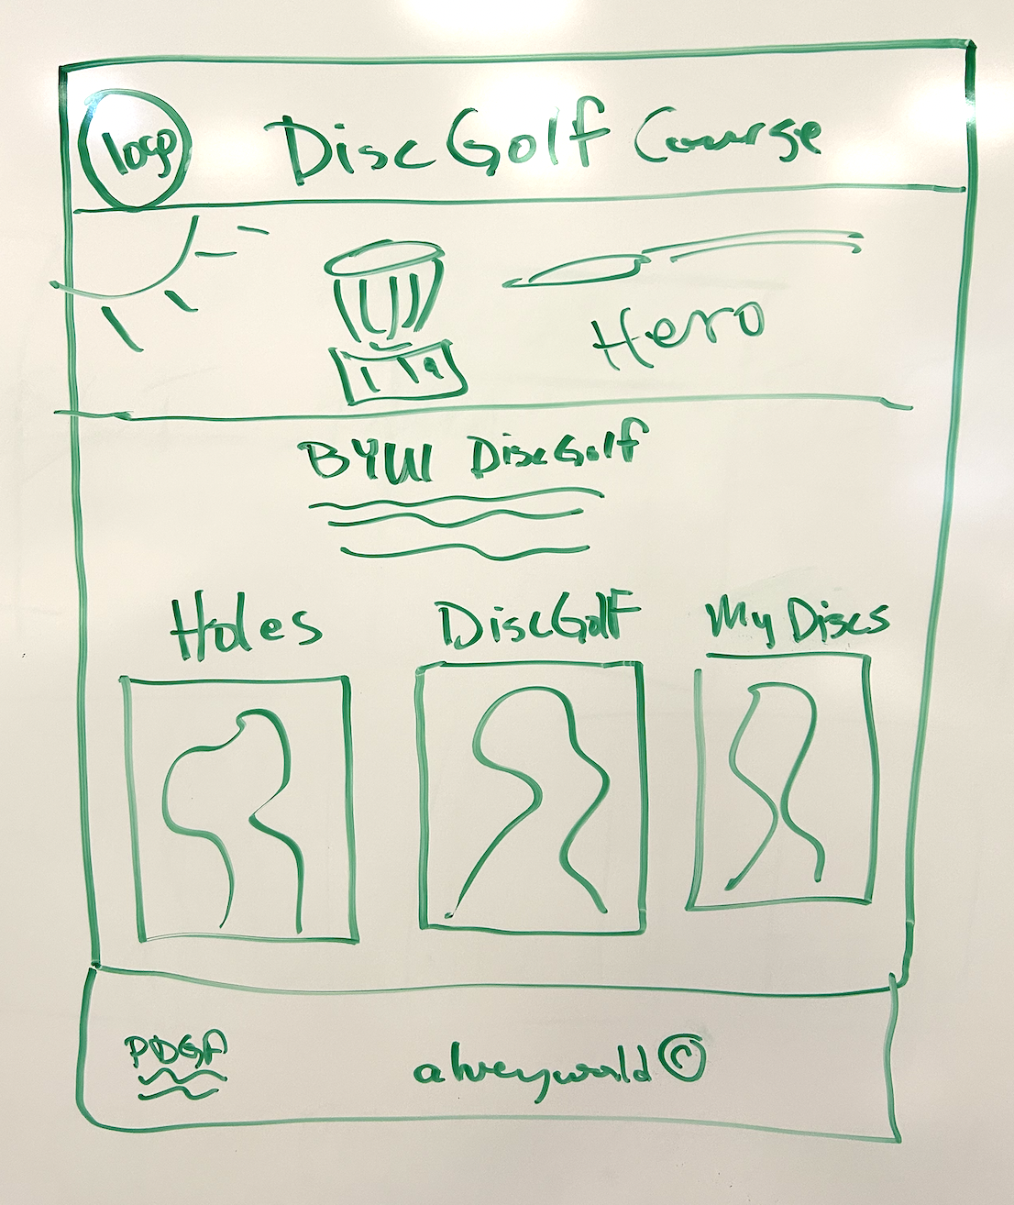

Sub Pages

